SUMMERVILLE CREDIT UNION · CONSOLIDATED MEMBER GUIDE
Usage Control

Module: nFinia Digital Banking > Cards > Card Details > Card Controls > Usage Control
01 PRODUCT SUMMARY

Usage Control gives you granular control over where and how your card can be used. You can enable or disable specific transaction types — such as In Store, ATM, Mail / Phone order, eCommerce, and more — as well as specific merchant categories like Department Store, Gas Station, Grocery, and Restaurant.
Each transaction type and merchant category can be toggled on or off individually. When a category is disabled, transactions of that type will be declined automatically regardless of the amount or location. This is especially useful for restricting card use to specific spending scenarios or preventing misuse on specific merchant types.

At a Glance
Attribute | Detail
Module | nFinia Digital Banking > Cards > Card Details > Card Controls > Usage Control
Transaction Types | In Store, ATM, Mail/Phone Order, eCommerce, Household, Restaurant, Grocery, Personal Care, Other, Age Restricted
Merchant Categories | Department Store, Gas Station, and more
Toggle | Each type/category controlled independently
Effect | Declined transactions for any disabled type or category
Related Features | Spending Limits, Location Controls, Card Alerts

02 KEY USE CASES

Use Case | Who Uses It | What They Do | Business Value
Block online purchases | Member wanting to prevent eCommerce fraud | Disables eCommerce transaction type under Usage Control | All online card transactions are declined
Restrict ATM withdrawals | Member who only uses card for purchases | Disables ATM transaction type | ATM withdrawals are blocked while in-store purchases still work
Limit merchant categories | Member managing a household budget | Disables specific merchant categories such as Restaurant or Age Restricted | Card is declined at those merchant types automatically
Re-enable a category | Member who needs to restore a transaction type | Toggles the disabled category back on | Card resumes accepting that type of transaction immediately

03 STEP-BY-STEP GUIDE

Navigation: Log in to Summerville Credit Union online banking. From the Dashboard, click Cards, select your card, click Card Controls, then select Usage Control.
Step 1 — Arrive at the Dashboard
After logging in, you land on the Dashboard. Click Cards in the top navigation, select your card, then open Card Controls from the Card Details page.
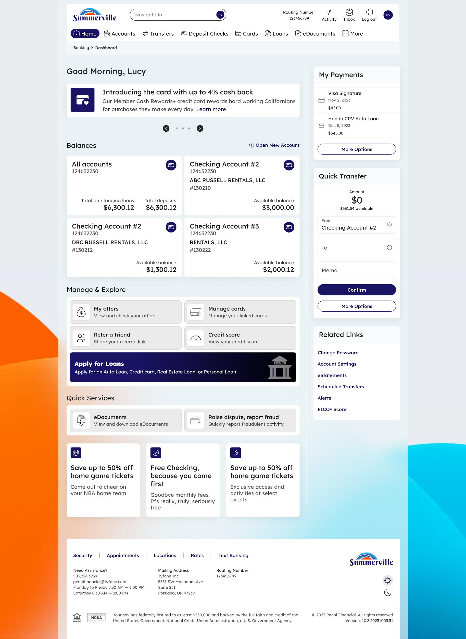
Step 1: Dashboard — click Cards to begin
Step 2 — Configure Transaction Types and Merchant Categories
The Usage Control tab displays two columns: Transaction Type and Merchant Categories. Each item has a toggle that can be turned on or off. Disabled items show an Off indicator. Toggle any type or category to control whether your card is accepted for that use. Changes take effect immediately — no save button is needed.
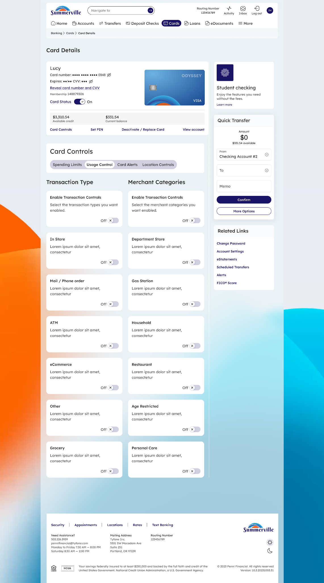
Step 2: Toggle individual transaction types and merchant categories on or off

